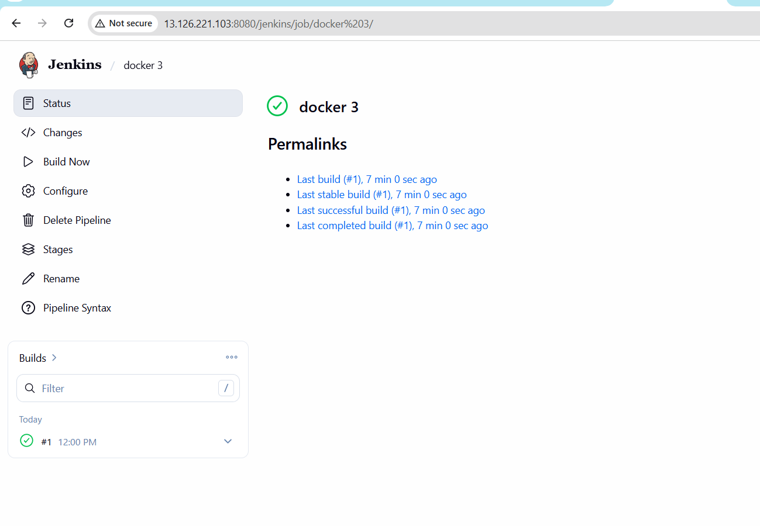
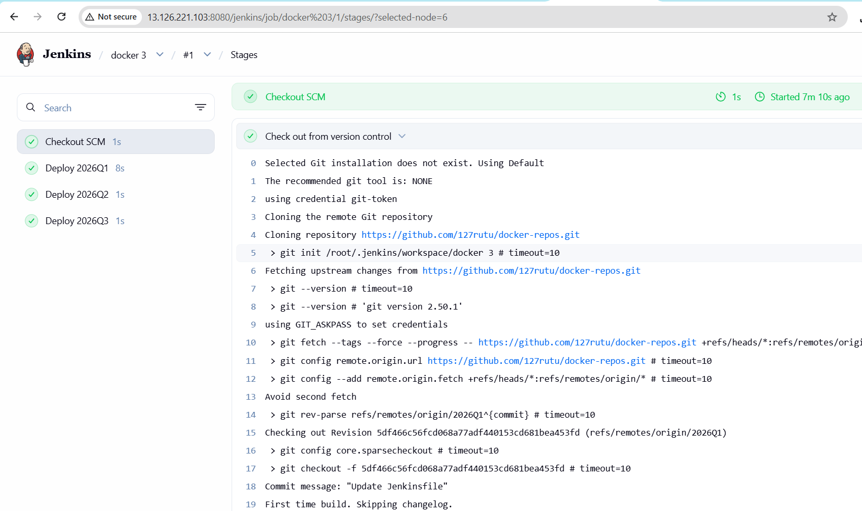
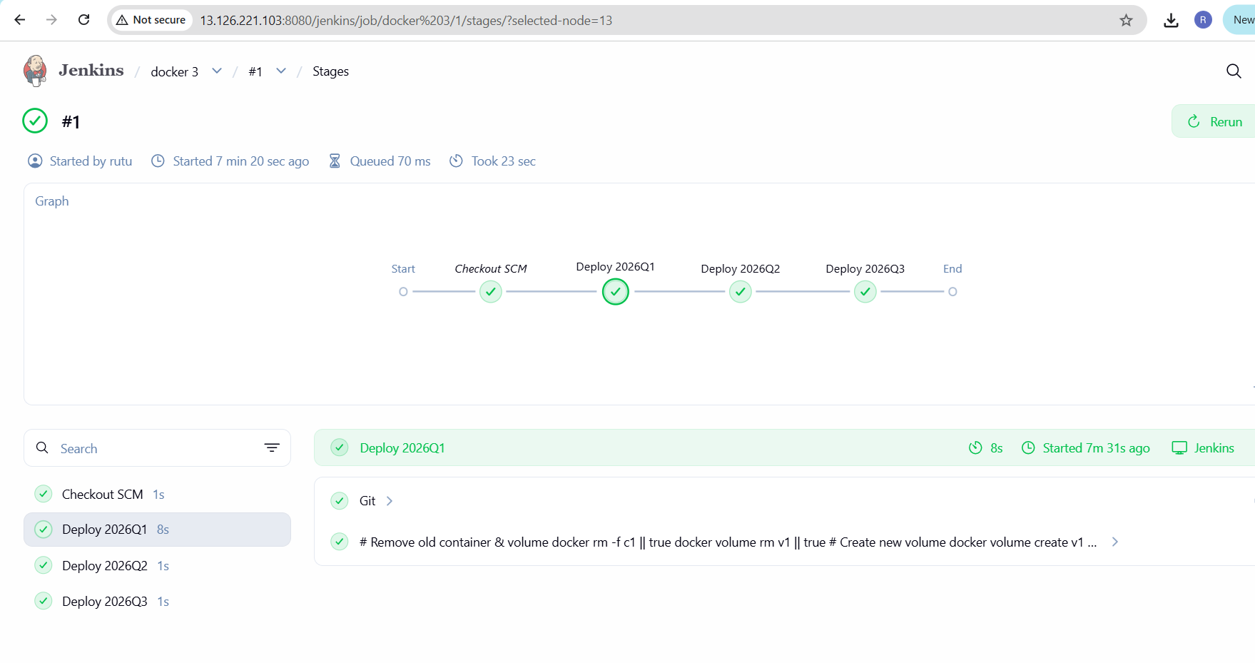
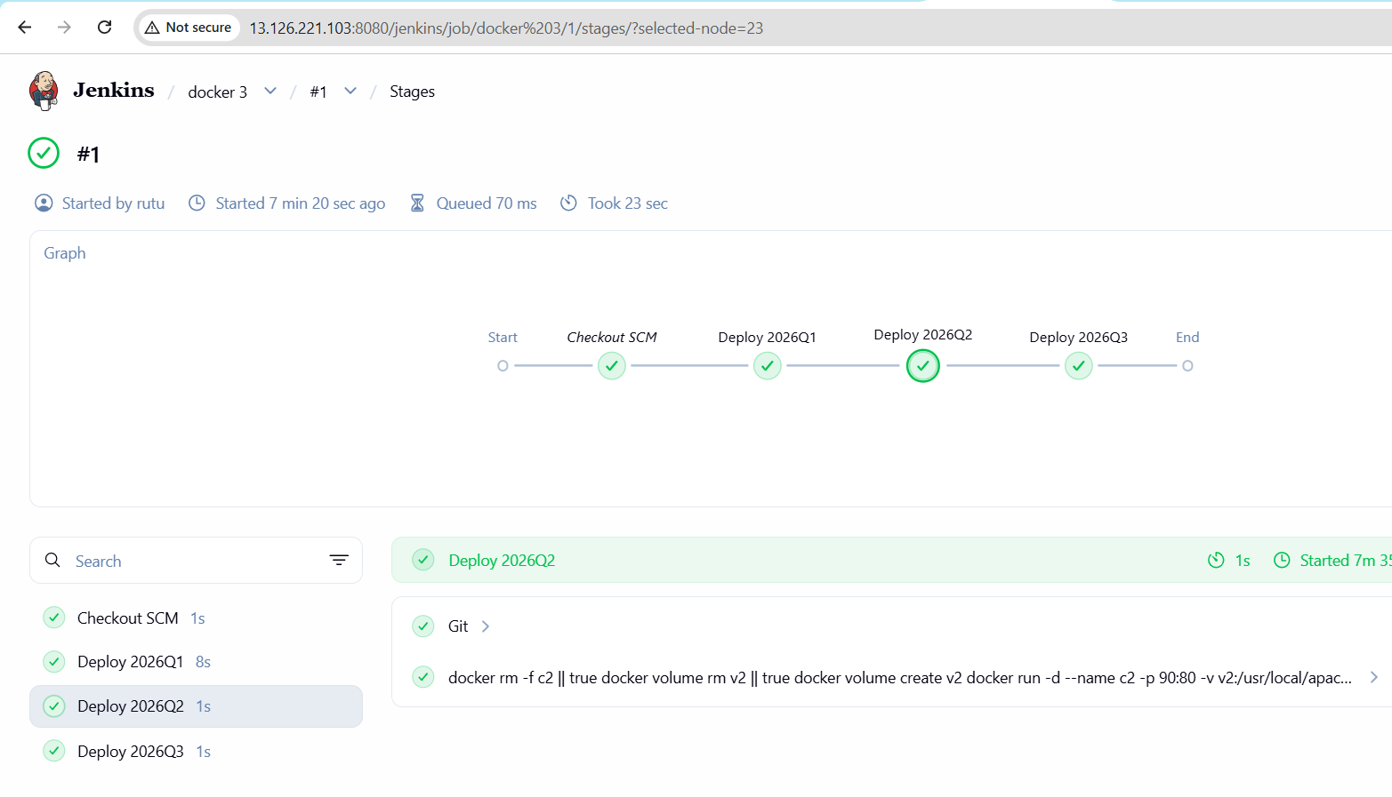
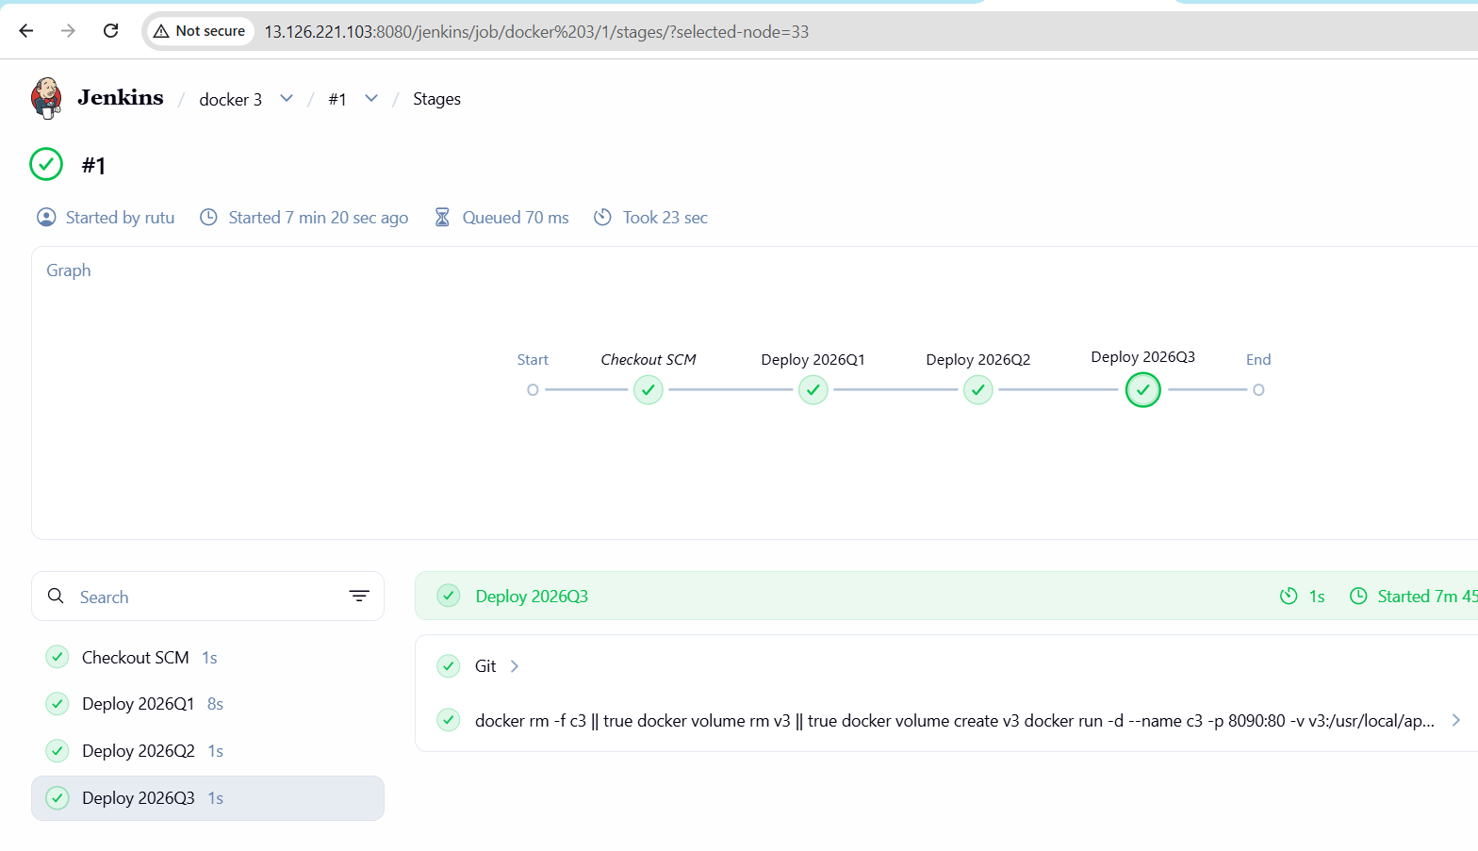
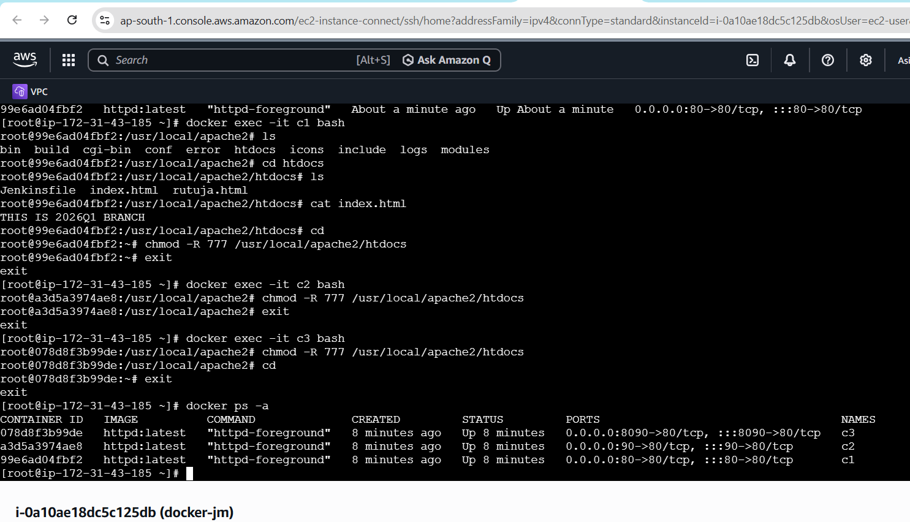
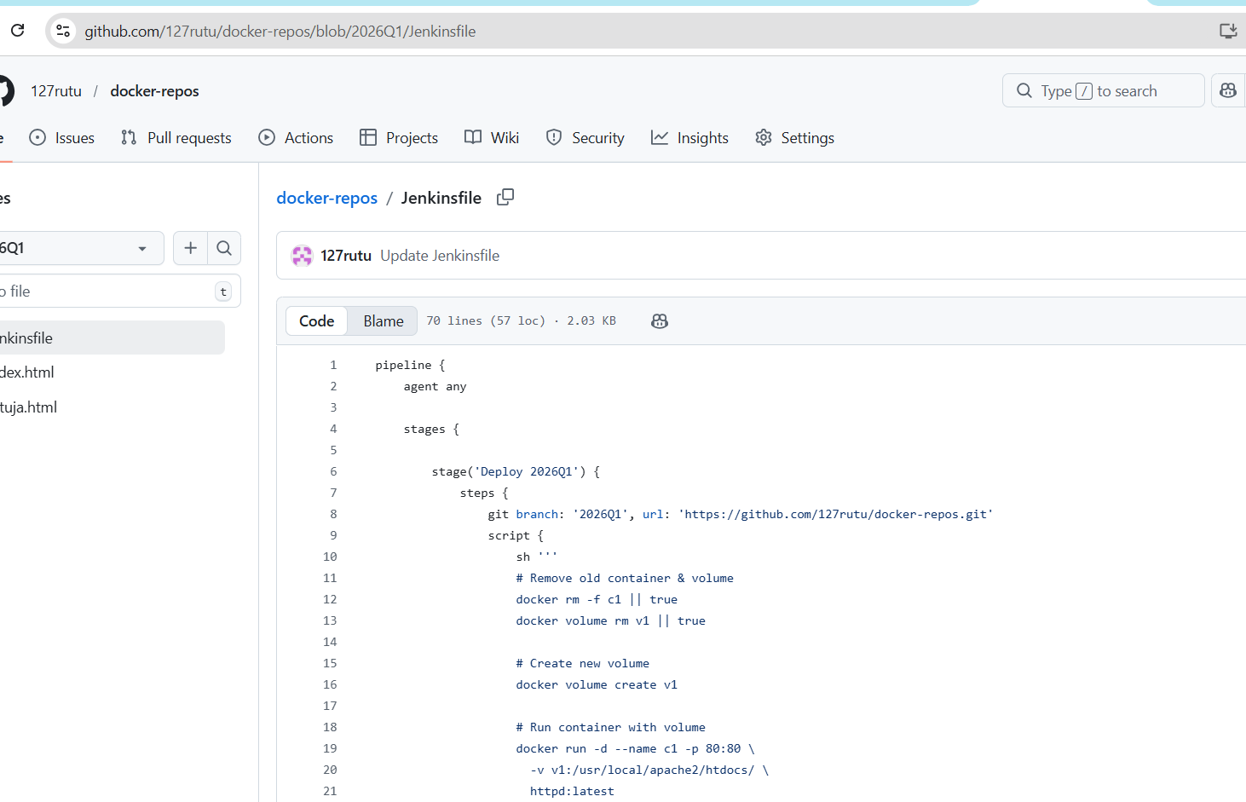
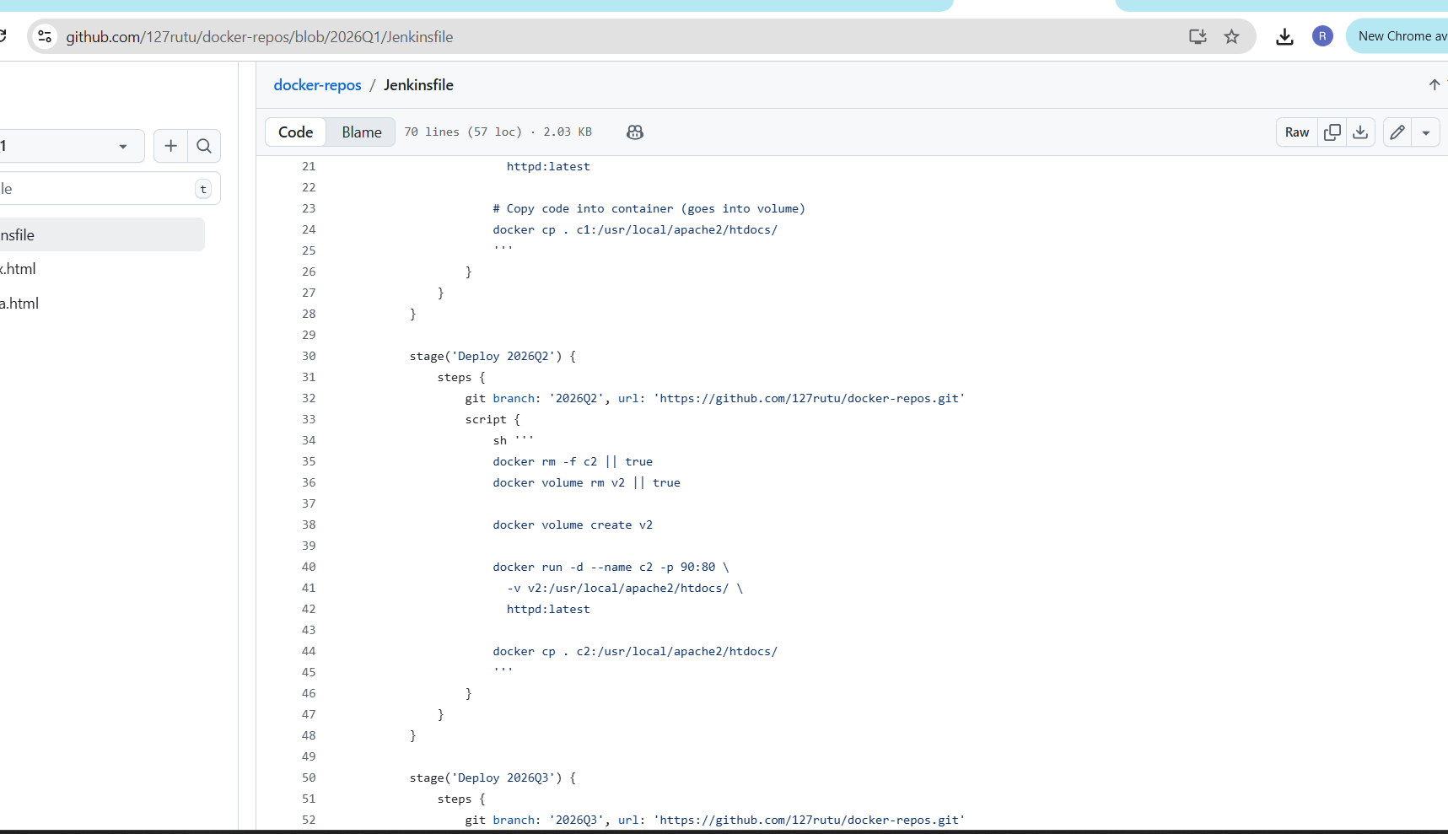
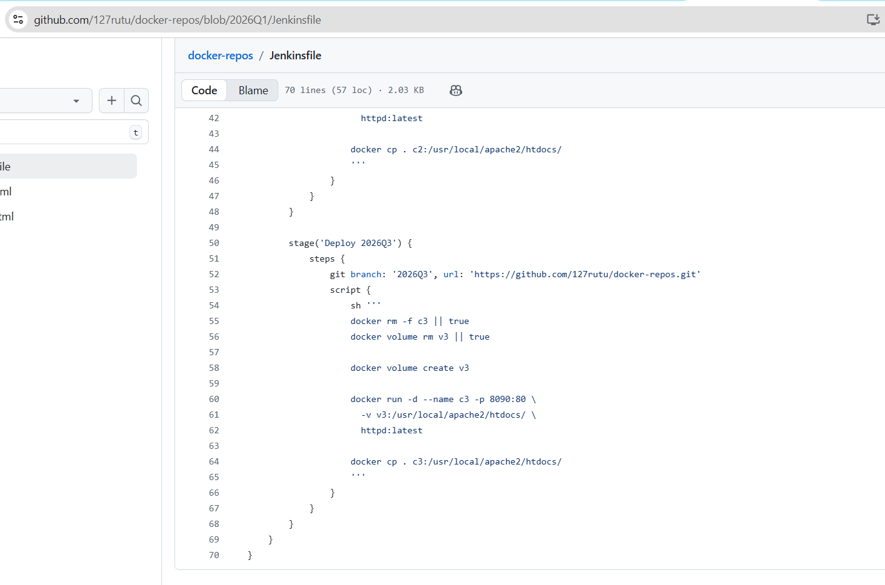
pipeline {
agent any

stages {

stage('Deploy 2026Q1') {
steps {
git branch: '2026Q1', url: 'https://github.com/127rutu/docker-repos.git'
script {
sh '''
# Remove old container & volume
docker rm -f c1 || true
docker volume rm v1 || true

# Create new volume
docker volume create v1

# Run container with volume
docker run -d --name c1 -p 80:80 \
-v v1:/usr/local/apache2/htdocs/ \
httpd:latest

# Copy code into container (goes into volume)
docker cp . c1:/usr/local/apache2/htdocs/
'''
}
}
}

stage('Deploy 2026Q2') {
steps {
git branch: '2026Q2', url: 'https://github.com/127rutu/docker-repos.git'
script {
sh '''
docker rm -f c2 || true
docker volume rm v2 || true

docker volume create v2

docker run -d --name c2 -p 90:80 \
-v v2:/usr/local/apache2/htdocs/ \
httpd:latest

docker cp . c2:/usr/local/apache2/htdocs/
'''
}
}
}

stage('Deploy 2026Q3') {
steps {
git branch: '2026Q3', url: 'https://github.com/127rutu/docker-repos.git'
script {
sh '''
docker rm -f c3 || true
docker volume rm v3 || true

docker volume create v3

docker run -d --name c3 -p 8090:80 \
-v v3:/usr/local/apache2/htdocs/ \
httpd:latest

docker cp . c3:/usr/local/apache2/htdocs/
'''
}
}
}
}
}
